**Bike_Parts**

1.Engine

2.Frame

3.wheels

4.Tires

5.Suspension

6.Brakes

7.Fuel Tank

8.Exhaust System

9. Handlebars

10.Throttle

11.Clutch

12.Gearbox

13.Chain or Belt Drive

14.Lights

15.Electrical System

**This list of consumables and replaceable parts would be mentioned in the service manual of every bike.**

**Consumables:**

🡪Engine oil

🡪Coolant (liquid cooled engine)

🡪Brake fluid

**Replaceable parts:**

🡪Oil filter ***

🡪Air filter ***

🡪Sprocket and Chain Set **

🡪Brake pads ***

🡪Clutch cable **

🡪Clutch plate *

🡪Spark plugs *

🡪Suspension oil seal (Upside down forks) **

🡪Steering cone set *

**LEGEND**

***Very frequently (every service interval)

**Frequently (once in two or three service intervals)

*Not so frequently (once or twice the bike's life time)

**Bikes, like any mechanical system, require periodic maintenance and replacement of parts to ensure optimal performance and safety. Here are some common bike parts that may need to be replaced over time:**

1. **Tires**: Worn-out tires can lead to poor traction and increased risk of flats. Check for tread wear and sidewall damage.
2. **Brake Pads**: Brake pads wear down with use. Regularly inspect them for thickness and replace them if they are worn to ensure effective braking.
3. **Chain**: Chains can stretch and wear out over time, leading to poor shifting and increased wear on other drivetrain components. Regularly check for wear and replace as needed.
4. **Cogs and Cassette**: The teeth on cogs and cassettes can wear down, especially if the chain is not replaced regularly. This can lead to skipping gears.
5. **Derailleurs**: Although they are sturdy, derailleurs can get damaged in crashes or from impacts. If shifting becomes erratic, it might be time for a replacement.
6. **Brake Cables and Housing**: Cables can fray and become less effective over time, affecting braking performance.
7. **Handlebar Grips or Tape**: Grips can wear out or become slippery, which can affect control and comfort.
8. **Saddle**: Over time, a saddle can become uncomfortable or damaged. Replacing it can improve comfort during rides.
9. **Bottom Bracket**: This component can wear out, leading to a creaking noise or play in the crankset.
10. **Pedals**: Pedals can wear out or get damaged, especially if they are subjected to heavy use or impacts.
11. **Wheel Bearings**: Bearings in the hubs can wear out, leading to rough spinning or play in the wheels.

**How to rebuild an engine step by step?**

**Step-by-Step Engine Rebuilding Process**

1. Step 1: Safety First. Disconnect and remove the battery to prevent electrical accidents. ...
2. Step 2: Drain Fluids. ...
3. Step 3: Remove Accessories. ...
4. Step 4: Disconnect Wiring and Hoses. ...
5. Step 5: Remove Engine Mounts. ...
6. Step 6: Lift the Engine.

**7 Common Motorcycle Repairs**

1. **Braking Systems:**

Depending on your riding style and type of motorcycle, brake pads can last hundreds or thousands of miles. However, there are times when brakes fail, and, as you know, this can be seriously dangerous on the road. Shockingly, motorcycle brake failure is also more common than you think with the likely culprit being prolonged use of the bike without servicing in line with the manufacturer’s recommendations. It is always best to check your brakes, amongst other critical parts of your motorcycle before setting off on any journey. If you can pull the brake lever even close to the handlebar grip or it feels spongy, it’s time to service your brakes.

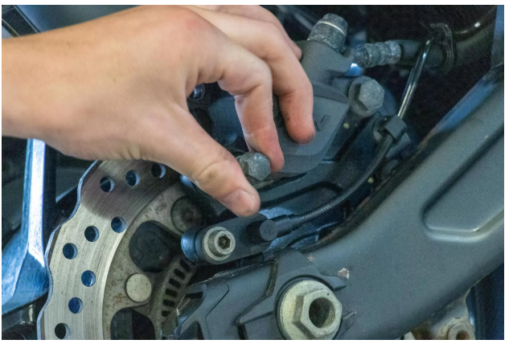

**2.Chain and Drive Systems:**

As with most components, chains require regular maintenance to work correctly. Signs of wear can take many different forms. You need to be on the lookout for kinks, missing or failing O-rings or X-rings, worn rollers and corrosion. Chains don’t tend to break suddenly but, over time, they can become fatigued which will worsen when not routinely maintained. Keep your chain clean, protected and lubricated to maximise chain life.

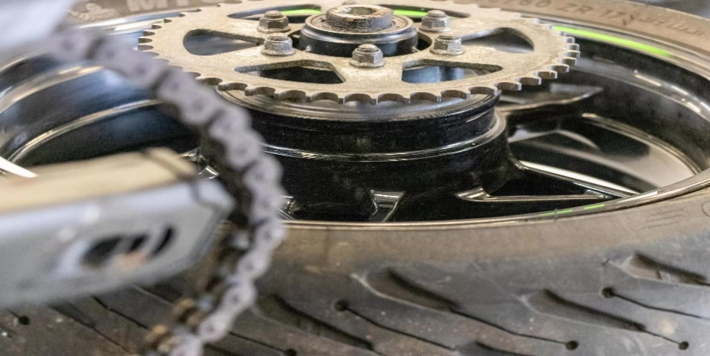

**3.Tyre Issues:**

Tyres can crack and tear for many reasons, from neglect, chemicals, underinflation and a process called ‘cold tear’. ‘Cold tear’ occurs when the tyre surface generates heat when riding but the internal face of the tyre is significantly colder, often as a result of over inflation. The result of ‘cold tear’ is the formation of cracks on the surface of the tyre. This can seem concerning however, there is a simple solution you can follow to prevent ‘cold tear’. Before setting off, check your tyre pressure to ensure they are showing the correct PSI.

Additionally, tyres can perish if underinflated, if you are planning to store your motorcycle for extended periods of time, make sure you inflate the tyres to their maximum PSI levels and store the bike on paddock stands to elevate the bike off the ground. The storage space should be dry and climate-controlled if possible**.**

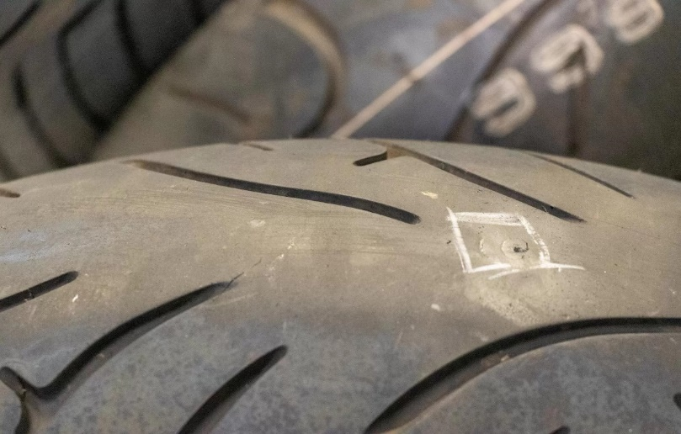

UK law demands a minimum tread depth of 1mm across ¾ of the tread pattern with visible tread on the remaining ¼ for bikes over 50cc. Under 50cc requires all the grooves of the original tread pattern to be visible – if any grooves have worn smooth, your tyre needs changing.That said, for safety reasons, we’d recommend changing your tyres prior to any of the tread wearing below 1mm.

**4.Suspension:**

Suspension is a critical part of the motorcycle for both handling and comfort. As suspension components start to wear out, increased feedback is received through the motorcycle as the suspension is not working as effectively.   
Suspension wear can happen in a variety of different ways and for different reasons, however one of the most common problems is dirt ingress to the fork seals. Overt time, dirt builds up on the suspension fork pistons and finds its way past the seals into the barrels. The dirt wears out the fork seals through abrasion and eventually can cause fork oil, when under compression, to seep past the seals which means the fork runs low on oil.

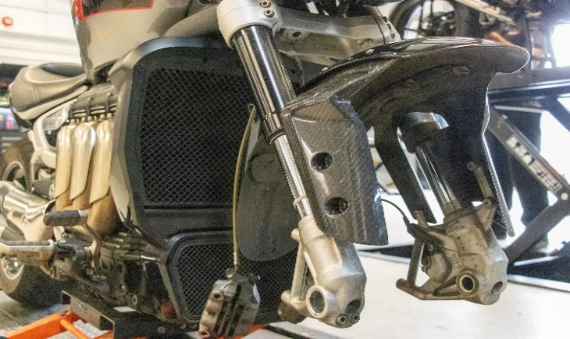

A proactive measure you can take to prolonging suspension fork seal life, is to make sure that you clean around the fork seals on a regular basis, it’s also a good idea to use fork gaiters, although this is not possible with every suspension fork setup.

**5.Electrical System Failures**

Like other vehicles, motorcycles are not immune to electrical faults. However, motorcycle problems often stem from simple causes, like loose or corroded connections. When performing your own motorcycle repairs think about the issue logically: if you experience multiple component failures, there may be a problem in the earth (ground) connection. Most circuitry is routed through the same earth connection. Additionally, you can perform your own continuity checks, voltage checks and earth (ground) checks.

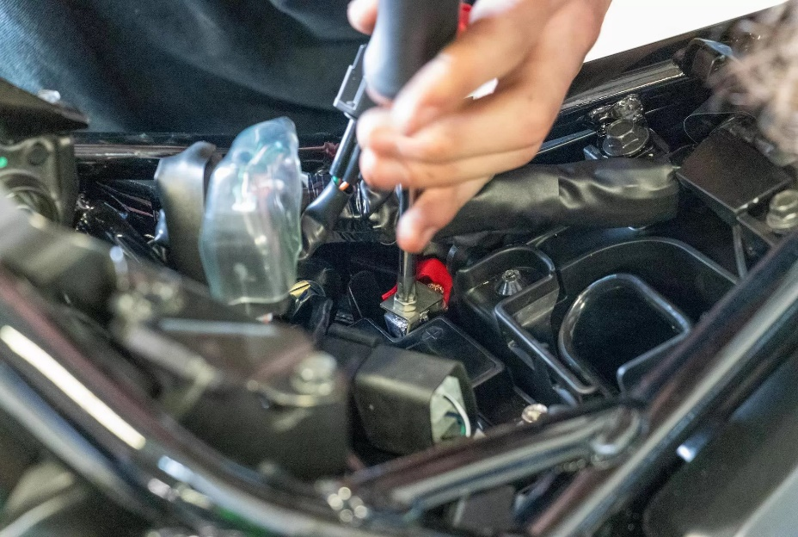

**6.Battery Issues**

Possibly one of the most common issues you’ll face with motorcycles are battery issues. This can be due to battery drain or the finite operational age of motorcycle batteries. If you experience battery drain, it is likely due to not enough power being produced back into the system. A common culprit for battery drain is poor ground connection between the frame and battery. Additionally, remember that motorcycle batteries tend to last between 2 to 5 years and be observant to the appearance of rust and corrosion. Regular checks of your battery during your motorcycle repairs will maintain its effectiveness through its operational life; consider using a battery maintenance charger if your motorcycle will be stood for longer periods of time.

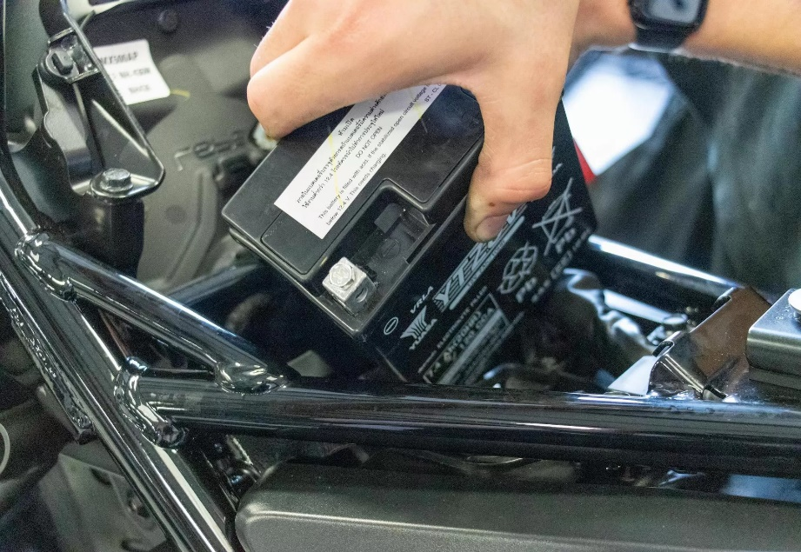

**7.Gearbox and Clutch Repairs:**

**Possibly the least common on our list are gearbox and clutch repairs. Your clutch or gearbox could break for a few different reasons. Firstly, your clutch won’t likely fail suddenly; instead, it will wear out over time when the friction plates lose their ability to provide ample friction from excessive heat. One sign you can tell that your clutch needs replacing is if the revs go up when you accelerate but the speed dial remains the same.**

**On the other hand, a gearbox can fail more suddenly and can break due to many different factors. For instance, your gearbox could fail as a result of corrosion, bent shift forks and incorrectly set chain tension. Some scenarios that would warn of an issue with your gearbox would be a burning smell accompanied usually with the sound of whirring and chattering from your transmission. If you experience these issues with your clutch or gearbox, you’ll need to repair or replace them immediately.**

